
CARITAS CHAN CHUN HA FIELD STUDIES CENTRE
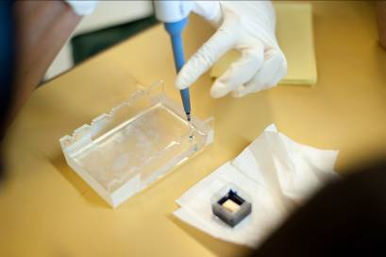
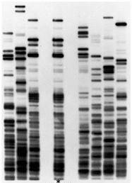

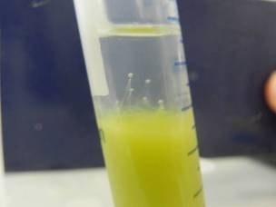
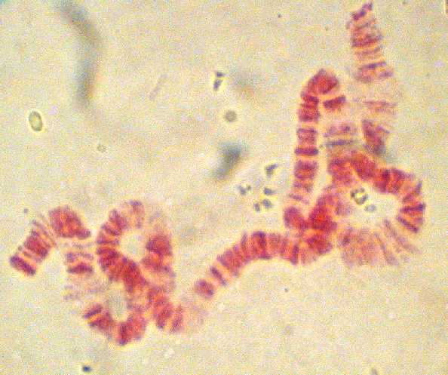

Biotechnology –
DNA Extraction, Gel Electrophroesis &
Observation of Polytene Chromosomes

School Name / Group
Student Name

DNA extraction from strawberries
Equipment and Materials |  |  | Chemicals
1ml Syringe  5ml Syringe  100ml Beaker  Cheese cloth or coffee filter  Filter funnel  Pestle and Mortar  Fruit Sample  Test tubes  Wooden sticks | X1  X1  X1  X1  X1  X1 set  X1  X1 |  | Extraction Buffer:  100 ml detergent  900 ml distilled water  15 grams NaCl | 10 ml
 | X1  X1  X1  X1  X1  X1 set  X1  X1 |  | Cold Alcohol (pre-measured) |  | 4 ml

Procedures
DNA Isolation using Strawberries (wear eye protection, or be careful).
- Mash the strawberries with pestle and mortar for 2 minutes.
- Add ~10 ml DNA Extraction buffer (Pre-measured).
- Mash for 1 minute.
- Filter solution by chess cloth/coffee filter into beaker
- Transfer ~2 ml of this solution back into the test tube. (It will be very red)
- Add ~4 ml (2X the volume of strawberry solution) of cold ethanol (found on freeze door in 50 ml tubes) slowly so that it lays on top of the strawberry solution.
- Record the observations

NOTE: a.) 1X volume of room temperature isopropanol, rubbing alcohol, as a substitute of alcohol.
b.) If the tube just sits, DNA will precipitate at the interface with bubbles. More DNA can be observed if the tube was shake in gently and eventually float to the top.

Discussion
- What is the function of extraction buffer?
- What is the function of alcohol? Why it should be cold?
- Why the fruit sample should be frozen beforehand?
- Why we usually select strawberries and Kiwi fruit as sample for DNA extraction?
- Why the yield of DNA extraction are different within different fruit sample?
- How to increase the yield of DNA extraction? Why?
- Is the precipitate as a pure DNA?
Principles
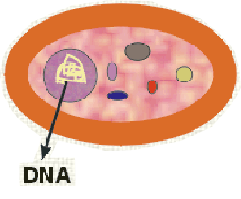  1. DNA is in the nucleus of the cell |  | 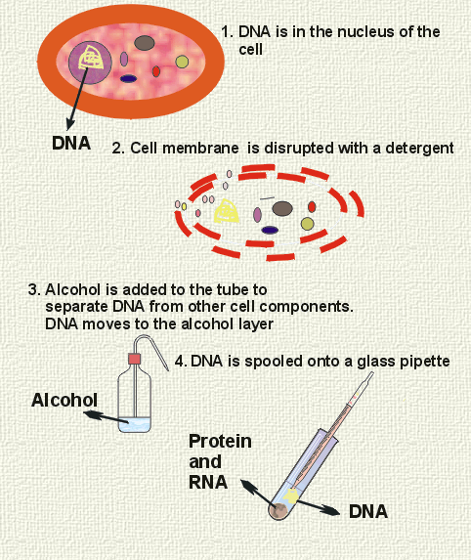  2. Cell membrane is disrupted with a detergent
`  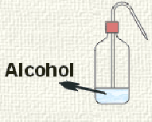  3. Cold Alcohol is added to the tube slowly to separate DNA form other cell components. DNA moves to the alcohol layer. |  | 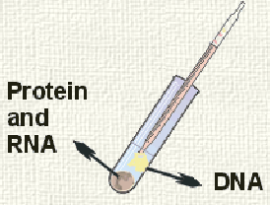  4. DNA is spooled onto wooden sticks.
DNA Fingerprinting
Deoxyribonucleic acid (DNA) is the genetic material that acts as the blueprint for protein synthesis by cells. In mammals, a large fraction of the total DNA does not code for proteins. Polymorphic DNA refers to chromosomal regions that vary among individuals. By examining several of these regions within genomic DNA, one can determine a “DNA Fingerprint” for an individual. DNA polymorphisms are now widely used for determining paternity/ maternity, identification of human remains and to determine the genetic basis of various inherited diseases. The most widely used and far-reaching application has been to field of criminal forensics. DNA from crime victims and offenders can now be definitively matched, affecting outcomes of criminal and civil trials.

Equipment and Materials |  | Chemicals
250 ml conical flask | X1 | Agarose | Share
Cooling basin | X1 | TAE buffer(1X) | 50ml
Digital thermometer | X1
Electronic balance | Share
Gel bed with comb  (Close off the open ends by paper tape) | X1 set
Microwave oven | Share
Microwave oven wrap | Share
Latex gloves | X1 pair
Pipettement and tips | X1 set
Procedures
Preparation of Agarose Gel (0.8% , 7 cm x 10 cm Gel)
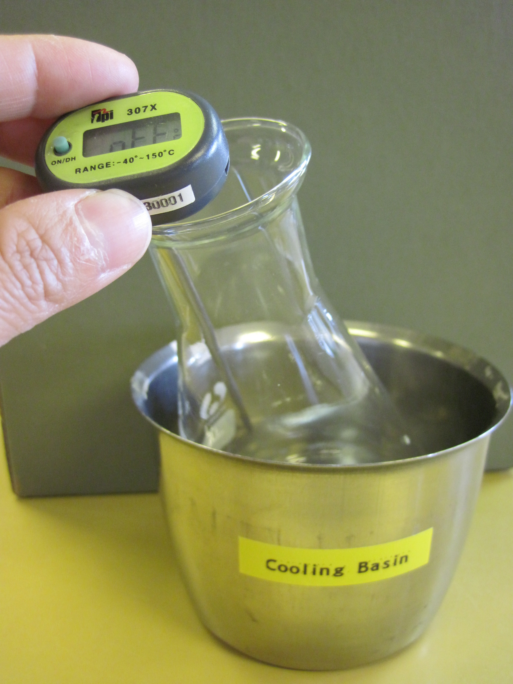
1. Put the conical flask on the electronic balance and set Zero.
2. Add 0.43g of agarose into the conical flask.
3. Add 50 ml 1x TAE buffer into the conical flask.
4. Wrap the opening of conical flask and make a hole on it.
5. Use a microwave oven to heat the mixture until all the agarose is completely dissolved. (Clear solution can be observed)
6. Cool the agarose solution to 55℃ with a cooling basin.
7. Pour the cooled agarose solution into the gel bed.
8. Allow the gel to completely solidify. It will become firm after approximately 20 minutes.
9. Remove the comb by slowly pulling straight up. Be careful and evenly to prevent tearing the sample wells.

Load the samples and Run the Gel
1. Load 25ul of the DNA samples from tubes A-E into the wells. The content of Tubes A-E is shown as follow,
- DNA Standard marker
- Crime scene PCR* reaction
- Suspect 1 PCR reaction
- Suspect 2 PCR reaction
- Suspect 3 PCR reaction
* PCR: Polymerase Chain Reaction

2. After DNA samples are loaded, connect the apparatus to the D.C. power source and set the power source at the required voltage.
3. Check that current is flowing properly – you should see bubbles forming on the two platinum electrodes. Conduct electrophoresis for the length of time specified by your instructor.
4. After electrophoresis is completed, proceed to DNA staining and visualization.

Staining and Destaining
- Completely submerse the agarose gel in a tray containing 1x FlashBlue Stain.
- Stain the gel for 5 minutes.
- Transfer the gel to another tray and fill it with distilled water.
- Gently agitate the tray every few minutes. Destain the gel for 20 minutes.
- Carefully remove the gel from the destaining liquid and examine the gel on a visible light gel visualization system.

Observation of Polytene Chromosomes in Larva of Chironomidae

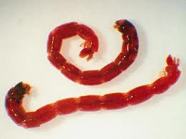
Polytene chromosomes are over-sized chromosomes, and are commonly found in cells which undergo repeated rounds of DNA replication without cell division, called endocyle. As the sister chromatids remain synapsed together, polytene chromosomes will be formed after multiple rounds of replication occurs. This kind of specialized cells may be found in the salivary glands of Drosophila.

Equipment and Materials |  | Chemicals
Chironomidae Larva | X1 pack | Aceto-orcein | Share
Forceps | X2 | Saline | Share
Filter paper | X few sheets
Slide | X3
Coverslip | X3
Stereomicroscope | X1
Light Microscope | X1

Procedures
- Prepare a clean slide with 2-3 drops of saline.
- Select a large larva and place it on the slide.
- Put the slide on a stereomicroscope.
- Use pins or forceps to grasp the larva by its middle part and its head respectively.
- Gently stretch the larva by pulling on it until its head separates from the rest of its body.
- Look for the salivary glands in the head section. The glands are very small, fairly transparent, usually paired and have dark fat particles attached.
- Soak the saline with filter paper.
- Add 2-3 drops of aceto-orcein stain to the salivary glands and keep it for 5-10 mins.
- After the stain has set, cover the salivary glands with coverslip.
- Place your thumb on the over the coverslip and press down slowly.

Discussion
- What are the benefits of having polyteny in the salivary glands?
- What are the similarities & differences between polyteny and polyploidy?

